
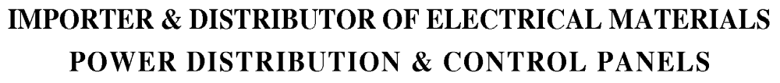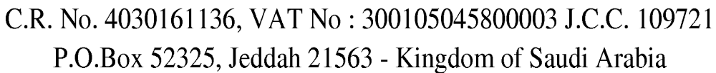

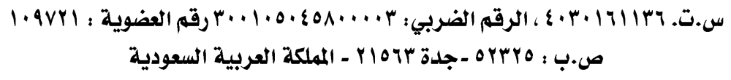

- SHOUKATH MOHAMMED ALI
Dept.(Sales)
Mobile: +966564676336
Email: shoukathnimra@gmail.com

- MOHAMMED RASI
Dept.(Sales)
Mobile: +966567850906
Email: sales@nimraelectric.com
Email: nimraelectric@gmail.com

- RAHMATH MIRZA
Dept.(Sales)
Mobile: +966508344852
Email: rahmathnimra@gmail.com

- SHUJAAT SYED AHMED
Dept.(Sales)
Mobile: +966508044763
Email: shujaatnimra@gmail.com

- SYED MUZAMMIL
Dept.(Sales)
Mobile: +966572164982
Email: muzammil@nimraelectric.com

- HUMRAZ ALI
Dept.(Accounts)
Mobile: +966572863873
Email: nimraelectric@gmail.com

Company Email which is using currently: nimraelectric@gmail.com
Chairman: MAQSOOD ALI KHAN Mobile: +966502718581/+966566677015

